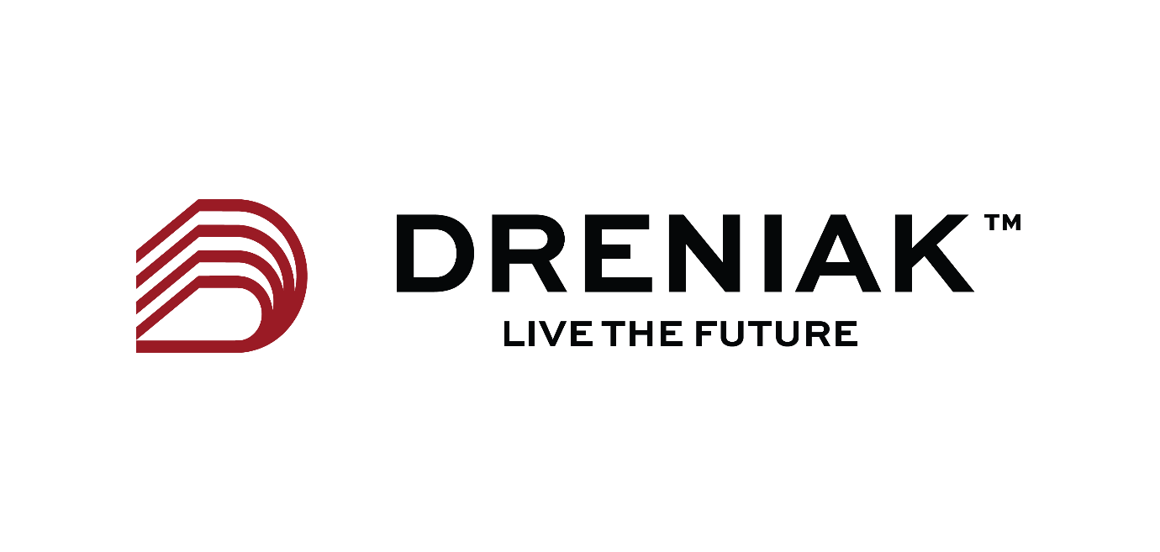

sDRENIAK

The story
The Story of Dreniak
Dreniak began with a boy who grew up in Africa with a simple but ambitious belief: Africa can build, manage and own world-class infrastructure — and take its rightful place on the global economic stage.
For me, engineering was the beginning. It taught me how we build. My love for economics made me ask a bigger question: how do the things we build create lasting value?
That question shaped Dreniak.
We evolved from engineering into Infrastructure & Asset Management — bringing together engineering, technology, data, finance and economics to help organisations and governments understand what they own, protect its value, invest intelligently and make infrastructure work harder for the economies it serves.
Our ambition goes beyond maintaining assets. We want to create infrastructure harmony: where buildings, transport, utilities, institutions and investment work together to strengthen businesses, communities and entire economies.
The vision is global, but Africa remains deeply personal.
We want to prove that world-class engineering and economic thinking can emerge from Africa, serve the world, and ultimately help the continent build greater capability, stronger institutions and lasting prosperity.
We have a long way to go.
But that is precisely why Dreniak exists.
We started with engineering. We are building towards economies.
Dreniak — Live the Future.

The values
WINNING — We compete to win. Winning means setting a world-class standard, delivering measurable value and refusing to accept that where we come from should determine how far we can go.
THINK GENERATIONS — We don't optimise for today alone. Every asset, investment and decision should be considered against the organisations, communities and economies it will serve decades from now.
QUESTION EVERYTHING — "That's how it's always been done" isn't a sufficient answer. We challenge assumptions, interrogate data and rethink engineering, investment and infrastructure from first principles.
BUILD BEYOND THE BRIEF — We solve the immediate engineering problem while understanding the bigger system around it. A building affects an organisation. Infrastructure affects productivity. Investment decisions can shape entire economies.
MAKE THE FUTURE PRACTICAL — Big ideas mean little without execution. We turn engineering, technology, data, finance and economics into solutions that can actually be built, managed, financed and scaled.

Service Pillars
1. Asset Intelligence & Strategic Management
We establish a complete understanding of infrastructure assets and translate that knowledge into strategy.
Includes: asset registers and portfolio mapping; condition and performance assessments; asset valuation and risk profiling; asset management strategies and plans; ISO 55000-aligned systems; governance, policies and reporting frameworks; estate and infrastructure portfolio strategies.
Economic value: Know what you own, what it is worth, what it needs and what it can become.
2. Lifecycle Engineering & Performance
We manage assets as long-term productive investments rather than short-term engineering projects.
Includes: lifecycle assessments; structural and engineering reviews; preventative and risk-based maintenance strategies; reliability and serviceability planning; rehabilitation and refurbishment strategies; useful-life extension; performance optimisation; replacement and disposal planning.
Economic value: Make existing infrastructure perform better, cost less and last longer.
3. Capital Planning, Finance & Investment Advisory
We connect the physical condition of infrastructure with the financial decisions surrounding it.
Includes: whole-life costing; CAPEX and OPEX planning; maintenance versus replacement analysis; capital prioritisation; investment appraisal; infrastructure financial modelling; portfolio investment planning; long-term funding requirements and asset liability forecasting.
Economic value: Put capital where it creates the greatest long-term return.
4. Digital Asset Management & Intelligence
We create the digital infrastructure required to understand and manage physical infrastructure intelligently.
Includes: digital asset registers; BIM and digital-twin frameworks; asset management platforms; performance dashboards; data collection and integration; monitoring systems; predictive insights; decision-support tools; portfolio-level asset intelligence.
Economic value: Turn infrastructure data into intelligence — and intelligence into better decisions.
5. Risk, Resilience & Sustainable Infrastructure
We identify what could compromise an asset's future performance and build strategies to protect it.
Includes: infrastructure risk assessments; structural and operational risk; resilience planning; climate and environmental considerations; business continuity; critical asset identification; sustainability strategies; compliance and safety considerations; long-term adaptation planning.
Economic value: Protect infrastructure, institutional continuity and capital from tomorrow's risks.
6. Infrastructure & Economic Strategy
This should become one of Dreniak's defining capabilities. We look beyond individual assets to understand how infrastructure portfolios influence organisations, communities and economies.
Includes: institutional infrastructure master planning; estate transformation; infrastructure investment strategy; portfolio optimisation; socioeconomic impact analysis; infrastructure demand and capacity planning; productivity analysis; strategic advisory for large organisations and governments; interconnected infrastructure planning and infrastructure harmony.
Economic value: Move from managing individual assets to building infrastructure systems that enable economic growth.
The six services therefore tell one continuous story:
UNDERSTAND → MANAGE → INVEST → DIGITISE → PROTECT → GROW
And underneath the entire Dreniak proposition:
We help organisations understand what they own, maximise how it performs, determine where capital should go, and ensure infrastructure creates value far beyond the asset itself.
Sectors
Dreniak Core Sectors
- Education & Institutional Estates — Universities, schools, research campuses and large educational networks where buildings, utilities, technology and land must perform as integrated long-term portfolios.
- Transport & Mobility Infrastructure — Roads, bridges, rail, airports, ports and associated infrastructure requiring lifecycle planning, resilience and major capital investment.
- Energy & Utilities — Power, renewable energy, water, wastewater and utility networks where reliability and asset performance directly influence economic productivity.
- Government & Public Infrastructure — Government estates, civic infrastructure and public asset portfolios where better asset intelligence can strengthen public investment and long-term value for taxpayers.
- Healthcare & Social Infrastructure — Hospitals, healthcare campuses and other critical social infrastructure where asset reliability, safety and continuity are fundamental to service delivery.
- Real Estate & Major Developments — Commercial estates, residential portfolios, mixed-use developments and major property holdings requiring lifecycle, investment and portfolio optimisation.
- Industrial, Manufacturing & Logistics — Factories, warehouses, distribution centres, industrial parks and productive assets where infrastructure performance directly affects output, efficiency and profitability.
- Cities & Economic Infrastructure — Large interconnected portfolios spanning transport, utilities, public buildings, land and essential infrastructure—allowing Dreniak to work towards its wider concept of Infrastructure Harmony.
The Dreniak niche
Rather than defining ourselves by one industry, I would define the niche as:
“We serve organisations, institutions and economies that own complex, long-life infrastructure.”
The Site
Recommended Dreniak Site Architecture
Page | Purpose
1. Home | The proposition immediately: who Dreniak is, what assets you manage, the problems you solve and the economic value you create.
2. About Dreniak | The Dreniak story, founder story, mission, 3-year vision, modern values and the thinking behind Live the Future.
3. Asset Management | Your flagship page explaining Dreniak's philosophy: asset lifecycle, value realisation, asset intelligence and how engineering + finance + economics come together.
4. Services | Your six core capabilities: Asset Intelligence & Strategy; Lifecycle Engineering; Capital Planning & Investment; Digital Asset Management; Risk & Resilience; Infrastructure & Economic Strategy.
5. Sectors | Government, energy & utilities, transport, cities, property, industry, healthcare and education—with the asset-management challenges you solve in each.
6. Projects & Impact | Case studies showing Problem → Intervention → Result → Long-term Value. Over time this should become one of the strongest pages on the website.
7. Asset Intelligence / Digital | Your technology proposition: asset registers, data, dashboards, BIM, digital twins, monitoring, analytics and eventually predictive asset intelligence.
8. Insights | Dreniak's intellectual platform: infrastructure economics, asset management, African infrastructure, lifecycle investment, capital efficiency and your Dreniak Decoded series.
9. Standards & Governance | ISO 55000/55001, ISO 19650, ISO 31000, environmental, safety, quality and applicable engineering/regulatory frameworks.
10. Sustainability & Resilience | How lifecycle extension, better utilisation, efficient capital allocation, energy performance and resilience reduce both economic and environmental costs.
11. Work With Us | Careers, engineering talent, economists, finance professionals, data specialists, partnerships, universities and research collaboration.
12. Contact / Start a Project | A commercially focused enquiry page—not simply “contact us”: Tell us about your assets, portfolio or infrastructure challenge.
I would not put all 12 pages in the top navigation. That would make an emerging Dreniak look unnecessarily complicated.
Your main navigation should be:
About | Asset Management | Services | Sectors | Projects | Insights | Contact
Then place Digital, Standards, Sustainability, Careers/Partnerships underneath those pages or in the footer.
There are also three pages I think could eventually distinguish Dreniak considerably.
Infrastructure & Economic Value could become a signature thought-leadership page explaining Dreniak's central thesis: infrastructure is not merely a physical asset; its condition, reliability and utilisation influence productivity, capital allocation and economic development.
Asset Management Maturity Assessment could eventually become an interactive commercial entry point. An organisation answers questions about its asset data, maintenance, lifecycle planning, governance, risk and capital planning, and Dreniak provides an indicative maturity score. That converts the website from a brochure into a lead-generation and diagnostic tool.
And eventually, Dreniak Intelligence could become the gateway into your client asset platform—portfolio dashboards, asset condition, risks, planned interventions, lifecycle expenditure and investment priorities.
That creates a much bigger trajectory for the website:
Today: Corporate website
Next: Infrastructure knowledge platform
Then: Asset diagnostic platform
Eventually: Infrastructure intelligence ecosystem
That final stage fits particularly well with the direction you've been building toward: Dreniak shouldn't only advise clients about assets; over time, it should aim to become part of the information infrastructure through which major asset owners understand and make decisions about those assets.

SEO
Simplified Asset Management SEO Terms
Core searches
- Asset Management Services
- Infrastructure Asset Management
- Building Asset Management
- Property Asset Management
- Asset Management Company
- Infrastructure Management Services
- Building Management Services
- Asset Management Consultancy
- Infrastructure Consultancy
- Asset Management Consultants
Condition, inspection & maintenance searches
- Building Condition Assessment
- Building Condition Survey
- Structural Condition Assessment
- Infrastructure Condition Assessment
- Building Inspection Services
- Asset Condition Survey
- Infrastructure Inspection
- Building Maintenance Planning
- Planned Maintenance Services
- Preventive Maintenance Planning
- Building Repair Assessment
- Infrastructure Maintenance
- Building Life Extension
- Asset Life Extension
Cost, investment & planning searches
- Building Lifecycle Cost
- Whole Life Costing
- Infrastructure Cost Assessment
- Property Maintenance Cost Planning
- Capital Expenditure Planning
- CAPEX Planning
- Asset Investment Planning
- Infrastructure Investment Planning
- Building Replacement Planning
- Asset Performance Review
- Property Portfolio Assessment
Uganda & East Africa
These should become particularly important for Dreniak:
- Asset Management Company Uganda
- Asset Management Services Uganda
- Infrastructure Asset Management Uganda
- Infrastructure Consultancy Uganda
- Building Condition Assessment Uganda
- Building Inspection Services Uganda
- Property Asset Management Uganda
- Asset Management Consultants Kampala
- Infrastructure Consultants Kampala
- Building Condition Survey Kampala
- Infrastructure Management East Africa
- Asset Management Consultancy East Africa
- Infrastructure Asset Management East Africa
Africa
For the longer-term brand positioning:
- Asset Management Africa
- Infrastructure Asset Management Africa
- Infrastructure Consultancy Africa
- Asset Management Company Africa
- Infrastructure Management Africa
- Infrastructure Consultants Africa
- Building Asset Management Africa
- Infrastructure Investment Africa
- Infrastructure Maintenance Africa
- Infrastructure Planning Africa
- Infrastructure Advisory Africa
UK
- Infrastructure Asset Management UK
- Asset Management Consultancy UK
- Asset Management Consultants UK
- Building Asset Management UK
- Infrastructure Consultancy UK
- Building Condition Assessment UK
- Asset Condition Survey UK
- Infrastructure Condition Assessment UK
- Lifecycle Costing UK
- Infrastructure Investment Planning UK
I would build Dreniak's SEO around five simple keyword families:
ASSET MANAGEMENT
Asset management services · Asset management company · Asset management consultants
BUILDINGS & INFRASTRUCTURE
Infrastructure asset management · Building asset management · Infrastructure management
CONDITION & MAINTENANCE
Building condition assessment · Asset condition survey · Infrastructure inspection · Maintenance planning
MONEY & INVESTMENT
Whole life costing · CAPEX planning · Infrastructure investment planning · Asset investment planning
LOCATION
Uganda · Kampala · East Africa · Africa · UK
The important SEO principle is to combine them naturally. For example:
“Infrastructure Asset Management Company in Uganda”
“Building Condition Assessment & Asset Management Services in Kampala”
“Infrastructure Asset Management Consultants across East Africa”
“Infrastructure Asset Management & Investment Planning in Africa”
These are far closer to how a property owner, university, developer, facilities director, investor or government procurement team might actually look for help than highly academic asset-management terminology.
I would also keep “ISO 55000 Asset Management” and “ISO 55001 Asset Management” in the secondary SEO layer. They will have lower search volumes, but the people searching them are potentially much more sophisticated institutional prospects.

